1995 ASEAN FRAMEWORK AGREEMENT ON SERVICES

Signed in Bangkok, Thailand on 15 December 1995

Article I Objectives 2

Article II Areas of Cooperation 2

Article III Liberalisation 3

Article IV Negotiation of Specific Commitments 3

Article V Mutual Recognition 3

Article VI Denial of Benefits 4

Article VII Settlement of Disputes 4

Article VIII Supplementary Agreements or Arrangements 4

Article IX Other Agreements 4

Article X Modification of Schedules of Specific Commitments 5

Article XI Institutional Arrangements 5

Article XII Amendments 5

Article XIII Accession of New Members 5

Article XIV Final Provision 5

The Governments of Brunei Darussalam, the Republic of Indonesia, Malaysia, the Republic of the Philippines, the Republic of Singapore, the Kingdom of Thailand, and the Socialist Republic of Vietnam, Member States of the Association of South East Asian Nations (hereinafter referred to as "ASEAN");

RECOGNISING the Singapore Declaration of 1992 which provides that ASEAN shall move towards a higher plane of economic cooperation to secure regional peace and prosperity;

RECALLING that the Heads of Government, at the Fourth Summit held in Singapore on 27-28 January 1992 declared that an ASEAN Free Trade Area (AFTA) shall be established in the region;

NOTING that the Framework Agreement on Enhancing ASEAN Economic Cooperation signed in Singapore on 28 January 1992 provides that ASEAN Member States shall explore further measures on border and non-border areas of cooperation to supplement and complement the liberalisation of trade;

RECOGNISING that intra-ASEAN economic cooperation will secure a liberal trading framework for trade in services which would strengthen and enhance trade in services among ASEAN Member States;

DESIRING to mobilise the private sector in the realisation of economic development of ASEAN Member States in order to improve the efficiency and competitiveness of their service industry sector;

REITERATING their commitments to the rules and principles of the General Agreement on Trade in Services (hereinafter referred to as "GATS") and noting that Article V of GATS permits the liberalising of trade in services between or among the parties to an economic integration agreement;

AFFIRMING that ASEAN Member States shall extend to one another preference in trade in services;

HAVE AGREED AS FOLLOWS:

Article I Objectives

The objectives of the Member States under the ASEAN Framework Agreement on Services (hereinafter referred to as "this Framework Agreement") are:

(a) to enhance cooperation in services amongst Member States in order to improve the efficiency and competitiveness, diversify production capacity and supply and distribution of services of their service suppliers within and outside ASEAN;

(b) to eliminate substantially restrictions to trade in services amongst Member States; and

(c) to liberalise trade in services by expanding the depth and scope of liberalisation beyond those undertaken by Member States under the GATS with the aim to realising a free trade area in services.

Article II Areas of Cooperation

1. All Member States shall participate in the cooperation arrangements under this Framework Agreement. However, taking cognizance of paragraph 3 of Article I of this Framework Agreement on Enhancing ASEAN Economic Cooperation, two or more Member States may proceed first if other Member States are not ready to implement these arrangements.

2. Member States shall strengthen and enhance existing cooperation efforts in service sectors and develop cooperation in sectors that are not covered by existing cooperation arrangements, through inter alia:

(a) establishing or improving infrastructural facilities;

(b) joint production, marketing and purchasing arrangements;

(c) research and development; and

(d) exchange of information.

3. Member States shall identify sectors for cooperation and formulate Action Plans, Programmes and Understandings that shall provide details on the nature and extent of cooperation.

Article III Liberalisation

Pursuant to Article 1 (c), Member States shall liberalise trade in services in a substantial number of sectors within a reasonable time-frame by:

(a) eliminating substantially all existing discriminatory measures and market access limitations amongst Member States; and

(b) prohibiting new or more discriminatory measures and market access limitations.

Article IV Negotiation of Specific Commitments

1. Member States shall enter into negotiations on measures affecting trade in specific service sectors. Such negotiations shall be directed towards achieving commitments which are beyond those inscribed in each Member State's schedule of specific commitments under the GATS and for which Member States shall accord preferential treatment to one another on an MFN basis.

2. Each Member State shall set out in a schedule, the specific commitments it shall undertake under paragraph 1.

3. The provisions of this Framework Agreement shall not be so construed as to prevent any Member State from conferring or according advantages to adjacent countries in order to facilitate exchanges limited to contiguous frontier zones of services that are both locally produced and consumed.

Article V Mutual Recognition

1. Each Member State may recognise the education or experience obtained, requirements met, or licenses or certifications granted in another Member State, for the purpose of licensing or certification of service suppliers. Such recognition may be based upon an agreement or arrangement[1] with the Member State concerned or may be accorded autonomously.

2. Nothing in paragraph 1 shall be so construed as to require any Member State to accept or to enter into such mutual recognition agreements or arrangements.

Article VI Denial of Benefits

The benefits of this Framework Agreement shall be denied to a service supplier who is a natural person of a non-Member State or a juridical person owned or controlled by persons of a non-Member State constituted under the laws of a Member State, but not engaged in substantive business operations in the territory of Member State(s)

Article VII   
Settlement of Disputes

1. The Protocol on Dispute Settlement Mechanism for ASEAN shall generally be referred to and applied with respect to any disputes arising from, or any differences between Member States concerning the interpretation or application of, this Framework Agreement or any arrangements arising therefrom.

2. A specific dispute settlement mechanism may be established for the purposes of this Framework Agreement which shall form an integral part of this Framework Agreement.

Article VIII   
Supplementary Agreements or Arrangements

Schedules of specific commitments and Understandings arising from subsequent negotiations under this Framework Agreement and any other agreements or arrangements, Action Plans and Programmes arising thereunder shall form an integral part of this Framework Agreement.

Article IX   
Other Agreements

1. This Framework Agreement or any action taken under it shall not affect the rights and obligations of the Member States under any existing agreements[2] to which they are parties.

2. Nothing in this Framework Agreement shall affect the rights of the Member States to enter into other agreements not contrary to the principles, objectives and terms of this Framework Agreement.

3. Upon the signing of this Framework Agreement, Member States shall promptly notify the ASEAN Secretariat of any agreements pertaining to or affecting trade in services to which that Member is a signatory.

Article X   
Modification of Schedules of Specific Commitments

1. A Member State may modify or withdraw any commitment in its schedule of specific commitments, at any time after three years from the date on which that commitment entered into force provided:

(a) that it notifies other Member States and the ASEAN Secretariat of the intent to modify or withdraw a commitment three months before the intended date of implementation of the modification or withdrawal; and

(b) that it enters into negotiations with an affected Member State to agree to necessary compensatory adjustment.

2. In achieving a compensatory adjustment, Member States shall ensure that the general level of mutually advantageous commitment is not less favourable to trade than that provided for in the schedules of specific commitments prior to such negotiations.

3. Compensatory adjustment shall be made on an MFN basis to all other Member States.

4. The SEOM with the endorsement of the AEM may draw up additional procedures to give effect to this Article.

Article XI   
Institutional Arrangements

1. The SEOM shall carry out such functions to facilitate the operation of this Framework Agreement and further its objectives, including the Organisation of the conduct of negotiations, review and supervision of the implementation of this Framework Agreement.

2. The ASEAN Secretariat shall assist SEOM in carrying out its functions, including providing the support for supervising, coordinating and reviewing the implementation of this Framework Agreement.

Article XII   
Amendments

The provisions of this Framework Agreement may be amended through the consent of all the Member States and such amendments shall become effective upon acceptance by all Member States.

Article XIII   
Accession of New Members

New Members of ASEAN shall accede to this Framework Agreement on terms and conditions agreed between them and signatories to this Framework Agreement.

Article XIV   
Final Provision

1. The terms and definitions and other provisions of the GATS shall be referred to and applied to matters arising under this Framework Agreement for which no specific provision has been made under it.

2. This Framework Agreement shall be deposited with the Secretary-General of ASEAN, who shall promptly furnish a certified copy thereof to each Member State.

3. This Framework Agreement shall enter into force upon the deposit of instruments of ratification or acceptance by all signatory governments with the Secretary-General of ASEAN.

**IN WITNESS WHEREOF**, the undersigned, being duly authorised by their respective Governments, have signed the ASEAN Framework Agreement on Services.

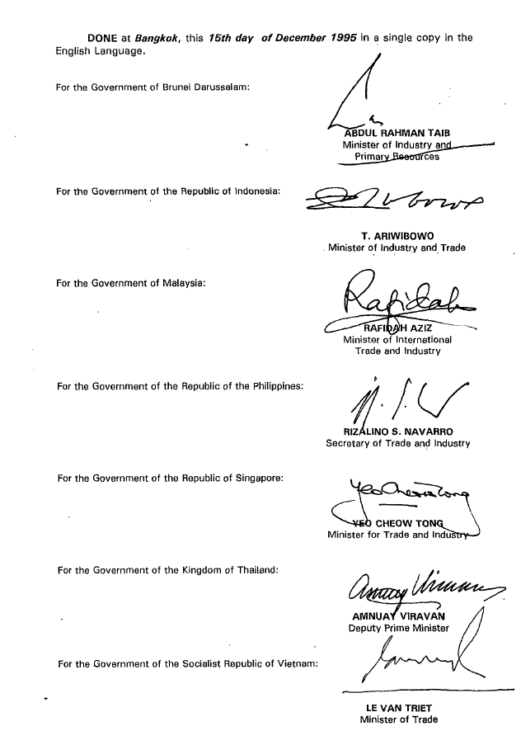

1. These agreements or arrangements are concluded for Member State only. In the event a Member State wishes to join such agreements or arrangements, it should be given equal opportunity to do at any time.
2. Existing Agreements are not affected as these have been notified in the MFN Exemption List of the GATS.