2002 ASEAN AGREEMENT ON TRANSBOUNDARY HAZE POLLUTION
Adopted in Kuala Lumpur, Malaysia on 10 June 2002

PART I. GENERAL PROVISIONS 4
Article 1. Use of Terms 4
Article 2. Objective 4
Article 3. Principles 5
Article 4. General Obligations 5
PART II. MONITORING, ASSESSMENT, PREVENTION AND RESPONSE 6
Article 5. ASEAN Co-ordinating Centre for Transboundary Haze Pollution Control 6
Article 6. Competent Authorities and Focal Points 6
Article 7. Monitoring 6
Article 8. Assessment 7
Article 9. Prevention 7
Article 10. Preparedness 7
Article 11. National Emergency Response 8
Article 12. Joint Emergency Response through the Provision of Assistance 8
Article 13. Direction and Control of Assistance 8
Article 14. Exemptions and Facilities in Respect of the Provision of Assistance 9
Article 15. Transit of Personnel, Equipment and Materials in Respect of the Provision of Assistance 9
PART III. TECHNICAL CO-OPERATION AND SCIENTIFIC RESEARCH 9
Article 16. Technical Co-operation 9
Article 17. Scientific Research 10
PART IV. INSTITUTIONAL ARRANGEMENTS 10
Article 18. Conference of the Parties 10
Article 19. Secretariat 10
Article 20. Financial Arrangements 11
PART V. PROCEDURES 11
Article 21. Protocols 11
Article 22. Amendments to the Agreement 11
Article 23. Adoption and Amendment of Annexes 12
Article 24. Rules of Procedure and Financial Rules 12
Article 25. Reports 12
Article 26. Relationship with Other Agreements 12
Article 27. Settlement of Disputes 12
PART VI. FINAL CLAUSES 13
Article 28. Ratification, Acceptance, Approval and Accession 13
Article 29. Entry into Force 13
Article 30. Reservations 13
Article 31. Depositary 13
Article 32. Authentic Text 13
16
ANNEX. Terms of Reference of the ASEAN Co-ordinating Centre for Transboundary Haze Pollution Control 18

2002 ASEAN AGREEMENT ON TRANSBOUNDARY HAZE POLLUTION
Adopted in Kuala Lumpur, Malaysia on 10 June 2002

The Parties to this Agreement,
REAFFIRMING the commitment to the aims and purposes of the Association of Southeast Asian Nations (ASEAN) as set forth in the Bangkok Declaration of 8 August 1967, in particular to promote regional co-operation in Southeast Asia in the spirit of equality and partnership and thereby contribute towards peace, progress and prosperity in the region,
RECALLING the Kuala Lumpur Accord on Environment and Development which was adopted by the ASEAN Ministers of Environment on 19 June 1990 which calls for, inter alia, efforts leading towards the harmonisation of transboundary pollution prevention and abatement practices,
RECALLING ALSO the adoption of the 1995 ASEAN Co-operation Plan on Transboundary Pollution, which specifically addressed transboundary atmospheric pollution and called for, inter alia, establishing procedures and mechanisms for co-operation among ASEAN Member States in the prevention and mitigation of land and/or forest fires and haze, DETERMINED to give effect to the 1997 Regional Haze Action Plan and to the Hanoi Plan of Action which call for fully implementing the 1995 ASEAN Cooperation Plan on Transboundary Pollution, with particular emphasis on the Regional Haze Action Plan by the year 2001,
RECOGNISING the existence of possible adverse effects of transboundary haze pollution,
CONCERNED that a rise in the level of emissions of air pollutants within the region as forecast may increase such adverse effects,
RECOGNISING the need to study the root causes and the implications of the transboundary haze pollution and the need to seek solutions for the problems identified,
AFFIRMING their willingness to further strengthen international cooperation to develop national policies for preventing and monitoring transboundary haze pollution,
AFFIRMING ALSO their willingness to co-ordinate national action for preventing and monitoring transboundary haze pollution through exchange of information, consultation, research and monitoring,
DESIRING to undertake individual and joint action to assess the origin, causes, nature and extent of land and/or forest fires and the resulting haze, to prevent and control the sources of such land and/or forest fires and the resulting haze by applying environmentally sound policies, practices and technologies and to strengthen national and regional capabilities and cooperation in assessment, prevention, mitigation and management of land and/or forest fires and the resulting haze,
CONVINCED that an essential means to achieve such collective action is the conclusion and effective implementation of an Agreement,
HAVE AGREED AS FOLLOWS:

PART I. GENERAL PROVISIONS

Article 1. Use of Terms
For the purposes of this Agreement:
1. “Assisting Party” means a State, international organisation, any other entity or person that offer and/or render assistance to a Requesting Party or a Receiving Party in the event of land and/or forest fires or haze pollution.
2. “Competent authorities” means one or more entities designated and authorised by each Party to act on its behalf in the implementation of this Agreement.
3. “Controlled burning” means any fire, combustion or smouldering that occurs in the open air, which is controlled by national laws, rules, regulations or guidelines and does not cause fire outbreaks and transboundary haze pollution.
4. “Fire prone areas” means areas defined by the national authorities as areas where fires are most likely to occur or have a higher tendency to occur.
5. “Focal point” means an entity designated and authorised by each Party to receive and transmit communications and data pursuant to the provisions of this Agreement.
6. “Haze pollution” means smoke resulting from land and/or forest fire which causes deleterious effects of such a nature as to endanger human health, harm living resources and ecosystems and material property and impair or interfere with amenities and other legitimate uses of the environment.
7. “Land and/or forest fires” means fires such as coal seam fires, peat fires, and plantation fires.
8. “Member State” means a Member State of the Association of Southeast Asian Nations.
9. “Open burning” means any fire, combustion or smouldering that occurs in the open air.
10. “Party” means a Member State of ASEAN that has consented to be bound by this Agreement and for which the Agreement is in force.
11. “Receiving Party” means a Party that accepts assistance offered by an Assisting Party or Parties in the event of land and/or forest fires or haze pollution.
12. “Requesting Party” means a Party that requests from another Party or Parties assistance in the event of land and/or forest fires or haze pollution.
13. “Transboundary haze pollution” means haze pollution whose physical origin is situated wholly or in part within the area under the national jurisdiction of one Member State and which is transported into the area under the jurisdiction of another Member State.
14. “Zero burning policy” means a policy that prohibits open burning but may allow some forms of controlled burning.

Article 2. Objective
The objective of this Agreement is to prevent and monitor transboundary haze pollution as a result of land and/or forest fires which should be mitigated, through concerted national efforts and intensified regional and international co-operation. This should be pursued in the overall context of sustainable development and in accordance with the provisions of this Agreement.

Article 3. Principles
The Parties shall be guided by the following principles in the implementation of this Agreement:
1. The Parties have, in accordance with the Charter of the United Nations and the principles of international law, the sovereign right to exploit their own resources pursuant to their own environmental and developmental policies, and the responsibility to ensure that activities within their jurisdiction or control do not cause damage to the environment and harm to human health of other States or of areas beyond the limits of national jurisdiction.
2. The Parties shall, in the spirit of solidarity and partnership and in accordance with their respective needs, capabilities and situations, strengthen co-operation and co-ordination to prevent and monitor transboundary haze pollution as a result of land and/or forest fires which should be mitigated.
3. The Parties should take precautionary measures to anticipate, prevent and monitor tranboundary haze pollution as a result of land and/or forest fires which should be mitigated, to minimise its adverse effects. Where there are threats of serious or irreversible damage from transboundary haze pollution, even without full scientific certainty, precautionary measures shall be taken by Parties concerned.
4. The Parties should manage and use their natural resources, including forest and land resources, in an ecologically sound and sustainable manner.
5. The Parties, in addressing transboundary haze pollution, should involve, as appropriate, all stakeholders, including local communities, non-governmental organisations, farmers and private enterprises.

Article 4. General Obligations
In pursuing the objective of this Agreement, the Parties shall:
1. Co-operate in developing and implementing measures to prevent and monitor transboundary haze pollution as a result of land and/or forest fires which should be mitigated, and to control sources of fires, including by the identification of fires, development of monitoring, assessment and early warning systems, exchange of information and technology, and the provision of mutual assistance.
2. When the transboundary haze pollution originates from within their territories, respond promptly to a request for relevant information or consultations sought by a State or States that are or may be affected by such transboundary haze pollution, with a view to minimising the consequences of the transboundary haze pollution.
3. Take legislative, administrative and/or other measures to implement their obligations under this Agreement.

PART II. MONITORING, ASSESSMENT, PREVENTION AND RESPONSE

Article 5. ASEAN Co-ordinating Centre for Transboundary Haze Pollution Control
1. The ASEAN Co-ordinating Centre for Transboundary Haze Pollution Control, hereinafter referred to as “the ASEAN Centre”, is hereby established for the purposes of facilitating operation and co-ordination among the Parties in managing the impact of land and/or forest fires in particular haze pollution arising from such fires.
2. The ASEAN Centre shall work on the basis that the national authority will act first to put out the fires. When the national authority declares an emergency situation, it may make a request to the ASEAN Centre to provide assistance.
3. A Committee composed of representatives of the national authorities of the Parties shall oversee the operation of the ASEAN Centre.
4. The ASEAN Centre shall carry out the functions as set out in Annex and any other functions as directed by the Conference of the Parties.

Article 6. Competent Authorities and Focal Points
1. Each Party shall designate one or more Competent Authorities and a Focal Point that shall be authorised to act on its behalf in the performance of the administrative functions required by this Agreement.
2. Each Party shall inform other Parties and the ASEAN Centre, of its Competent Authorities and Focal Point, and of any subsequent changes in their designations.
3. The ASEAN Centre shall regularly and expeditiously provide to Parties and relevant international organisations the information referred to in paragraph 2 above.

Article 7. Monitoring
1. Each Party shall take appropriate measures to monitor:
a. all fire prone areas,
b. all land and/or forest fires,
c. the environmental conditions conducive to such land and/or forest fires, and
d. haze pollution arising from such land and/or forest fires.
2. Each Party shall designate one or more bodies to function as National Monitoring Centres, to undertake monitoring referred to in paragraph 1 above in accordance with their respective national procedures.
3. The Parties, in the event that there are fires, shall initiate immediate action to control or to put out the fires.

Article 8. Assessment
1. Each Party shall ensure that its National Monitoring Centre, at agreed regular intervals, communicates to the ASEAN Centre, directly or through its Focal Point, data obtained relating to fire prone areas, land and/or forest fires, the environmental conditions conducive to such land and/or forest fires, and haze pollution arising from such land and/or forest fires.
2. The ASEAN Centre shall receive, consolidate and analyse the data communicated by the respective National Monitoring Centres or Focal Points.
3. On the basis of analysis of the data received, the ASEAN Centre shall, where possible, provide to each Party, through its Focal Point, an assessment of risks to human health or the environment arising from land and/or forest fires and the resulting transboundary haze pollution.

Article 9. Prevention
Each Party shall undertake measures to prevent and control activities related to land and/or forest fires that may lead to transboundary haze pollution, which include:
a. Developing and implementing legislative and other regulatory measures, as well as programmes and strategies to promote zero burning policy to deal with land and/or forest fires resulting in transboundary haze pollution;
b. Developing other appropriate policies to curb activities that may lead to land and/or forest fires;
c. Identifying and monitoring areas prone to occurrence of land and/or forest fires;
d. Strengthening local fire management and firefighting capability and co-ordination to prevent the occurrence of land and/or forest fires;
e. Promoting public education and awareness-building campaigns and strengthening community participation in fire management to prevent land and/or forest fires and haze pollution arising from such fires;
f. Promoting and utilising indigenous knowledge and practices in fire prevention and management; and
g. Ensuring that legislative, administrative and/or other relevant measures are taken to control open burning and to prevent land clearing using fire.

Article 10. Preparedness
1. The Parties shall, jointly or individually, develop strategies and response plans to identify, manage and control risks to human health and the environment arising from land and/or forest fires and related haze pollution arising from such fires.
2. The Parties shall, as appropriate, prepare standard operating procedures for regional co-operation and national action required under this Agreement.

Article 11. National Emergency Response
1. Each Party shall ensure that appropriate legislative, administrative and financial measures are taken to mobilise equipment, materials, human and financial resources required to respond to and mitigate the impact of land and/or forest fires and haze pollution arising from such fires.
2. Each Party shall forthwith inform other Parties and the ASEAN Centre of such measures.

Article 12. Joint Emergency Response through the Provision of Assistance
1. If a Party needs assistance in the event of land and/or forest fires or haze pollution arising from such fires within its territory, it may request such assistance from any other Party, directly or through the ASEAN Centre, or, where appropriate, from other States or international organisations.
2. Assistance can only be employed at the request of and with the consent of the requesting Party, or, when offered by another Party or Parties, with the consent of the receiving Party.
3. Each Party to which a request for assistance is directed shall promptly decide and notify the requesting Party, directly or through the ASEAN Centre, whether it is in a position to render the assistance requested, and of the scope and terms of such assistance.
4. Each Party to which an offer of assistance is directed shall promptly decide and notify the assisting Party, directly or through the ASEAN Centre, whether it is in a position to accept the assistance offered, and of the scope and terms of such assistance.
5. The requesting Party shall specify the scope and type of assistance required and, where practicable, provide the assisting Party with such information as may be necessary for that Party to determine the extent to which it is able to meet the request. In the event that it is not practicable for the requesting Party to specify the scope and type of assistance required, the requesting Party and assisting Party shall, in consultation, jointly assess and decide upon the scope and type of assistance required.
6. The Parties shall, within the limits of their capabilities, identify and notify the ASEAN Centre of experts, equipment and materials which could be made available for the provision of assistance to other Parties in the event of land and/or forest fires or haze pollution resulting from such fires as well as the terms, especially financial, under which such assistance could be provided.

Article 13. Direction and Control of Assistance
Unless otherwise agreed:
1. The requesting or receiving Party shall exercise the overall direction, control, co-ordination and supervision of the assistance within its territory. The assisting Party should, where the assistance involves personnel, designate in consultation with the requesting or receiving Party, the person or entity who should be in charge of and retain immediate operational supervision over the personnel and the equipment provided by it. The designated person or entity should exercise such supervision in co-operation with the appropriate authorities of the requesting or receiving Party.
2. The requesting or receiving Party shall provide, to the extent possible, local facilities and services for the proper and effective administration of the assistance. It shall also ensure the protection of personnel, equipment and materials brought into its territory by or on behalf of the assisting Party for such purposes.
3. A Party providing or receiving assistance in response to a request referred to in paragraph (1) above shall co-ordinate that assistance within its territory.

Article 14. Exemptions and Facilities in Respect of the Provision of Assistance
1. The requesting or receiving Party shall accord to personnel of the assisting Party and personnel acting on its behalf, the necessary exemptions and facilities for the performance of their functions.
2. The requesting or receiving Party shall accord the assisting Party exemptions from taxation, duties or other charges on the equipment and materials brought into the territory of the requesting or receiving Party for the purpose of the assistance.
3. The requesting or receiving Party shall facilitate the entry into, stay in and departure from its territory of personnel and of equipment and materials involved or used in the assistance.

Article 15. Transit of Personnel, Equipment and Materials in Respect of the Provision of Assistance
Each Party shall, at the request of the Party concerned, seek to facilitate the transit through its territory of duly notified personnel, equipment and materials involved or used in the assistance to the requesting or receiving Party.

PART III. TECHNICAL CO-OPERATION AND SCIENTIFIC RESEARCH

Article 16. Technical Co-operation
1. In order to increase the preparedness for and to mitigate the risks to human health and the environment arising from land and/or forest fires or haze pollution arising from such fires, the Parties shall undertake technical co-operation in this field, including the following:
a. Facilitate mobilisation of appropriate resources within and outside the Parties;
b. Promote the standardisation of the reporting format of data and information;
c. Promote the exchange of relevant information, expertise, technology, techniques and know-how;
d. Provide or make arrangements for relevant training, education and awareness-raising campaigns, in particular relating to the promotion of zero-burning practices and the impact of haze pollution on human health and the environment;
e. Develop or establish techniques on controlled burning particularly for shifting cultivators and small farmers, and to exchange and share experiences on controlled-burning practices;
f. Facilitate exchange of experience and relevant information among enforcement authorities of the Parties;
g. Promote the development of markets for the utilisation of biomass and appropriate methods for disposal of agricultural wastes;
h. Develop training programmes for firefighters and trainers to be trained at local, national and regional levels; and
i. Strengthen and enhance the technical capacity of the Parties to implement this Agreement.
2. The ASEAN Centre shall facilitate activities for technical cooperation as identified in paragraph 1 above.

Article 17. Scientific Research
The Parties shall individually or jointly, including in co-operation with appropriate international organisations, promote and, whenever possible, support scientific and technical research programmes related to the root causes and consequences of transboundary haze pollution and the means, methods, techniques and equipment for land and/or forest fire management, including firefighting.

PART IV. INSTITUTIONAL ARRANGEMENTS

Article 18. Conference of the Parties
1. A Conference of the Parties is hereby established. The first meeting of the Conference of the Parties shall be convened by the Secretariat not later than one year after the entry into force of this Agreement. Thereafter, ordinary meetings of the Conference of the Parties shall be held at least once every year, in as far as possible in conjunction with appropriate meetings of ASEAN.
2. Extraordinary meetings shall be held at any other time upon the request of one Party provided that such request is supported by at least one other Party.
3. The Conference of the Parties shall keep under continuous review and evaluation the implementation of this Agreement and to this end shall:
a. Take such action as is necessary to ensure the effective implementation of this Agreement;
b. Consider reports and other information which may be submitted by a Party directly or through the Secretariat;
c. Consider and adopt protocols in accordance with the Article 21 of this Agreement;
d. Consider and adopt any amendment to this Agreement;
e. Adopt, review and amend as required any Annexes to this Agreement;
f. Establish subsidiary bodies as may be required for the implementation of this Agreement; and
g. Consider and undertake any additional action that may be required for the achievement of the objective of this Agreement.

Article 19. Secretariat
1. A Secretariat is hereby established.
2. The functions of the Secretariat shall include:
a. Arrange for and service meetings of the Conference of the Parties and of other bodies established by this Agreement;
b. Transmit to the Parties notifications, reports and other information received in accordance with this Agreement;
c. Consider inquiries by, and information from, the Parties, and to consult with them on questions relating to this Agreement;
d. Ensure the necessary co-ordination with other relevant international bodies and in particular to enter into administrative arrangements as may be required for the effective discharge of the Secretariat functions; and
e. Perform such other functions as may be assigned to it by the Parties.
3. The ASEAN Secretariat shall serve as the Secretariat to this Agreement.

Article 20. Financial Arrangements
1. A Fund is hereby established for the implementation of this Agreement.
2. It shall be known as the ASEAN Transboundary Haze Pollution Control Fund.
3. The Fund shall be administered by the ASEAN Secretariat under the guidance of the Conference of the Parties.
4. The Parties shall, in accordance with the decisions of the Conference of the Parties, make voluntary contributions to the Fund.
5. The Fund shall be open to contributions from other sources subject to the agreement of or approval by the Parties.
6. The Parties may, where necessary, mobilise additional resources required for the implementation of this Agreement from relevant international organisations, in particular regional financial institutions and the international donor community.

PART V. PROCEDURES

Article 21. Protocols
1. The Parties shall co-operate in the formulation and adoption of protocols to this Agreement, prescribing agreed measures, procedures and standards for the implementation of this Agreement.
2. The Conference of the Parties may, at ordinary meetings, adopt protocols to this Agreement by consensus of all Parties.
3. The text of any proposed protocol shall be communicated to the Parties by the Secretariat at least six months before such a session.
4. The requirements for the entry into force of any protocol shall be established by that instrument.

Article 22. Amendments to the Agreement
1. Any Party may propose amendments to the Agreement.
2. The text of any proposed amendment shall be communicated to the Parties by the Secretariat at least six months before the Conference of the Parties at which it is proposed for adoption. The Secretariat shall also communicate proposed amendments to the signatories to the Agreement.
3. Amendments shall be adopted by consensus at an ordinary meeting of the Conference of the Parties.
4. Amendments to this Agreement shall be subject to acceptance. The Depositary shall circulate the adopted amendment to all Parties for their acceptance. The amendment shall enter into force on the thirtieth day after the deposit with the Depositary of the instruments of acceptance of all Parties.
5. After the entry into force of an amendment to this Agreement any new Party to this Agreement shall become a Party to this Agreement as amended.

Article 23. Adoption and Amendment of Annexes
1. Annexes to this Agreement shall form an integral part of the Agreement and, unless otherwise expressly provided, a reference to the Agreement constitutes at the same time a reference to the annexes thereto.
2. Annexes shall be adopted by consensus at an ordinary meeting of the Conference of the Parties.
3. Any Party may propose amendments to an Annex.
4. Amendments to an Annex shall be adopted by consensus at an ordinary meeting of the Conference of the Parties.
5. Annexes to this Agreement and amendments to Annexes shall be subject to acceptance. The Depositary shall circulate the adopted Annex or the adopted amendment to an Annex to all Parties for their acceptance. The Annex or the amendment to an Annex shall enter into force on the thirtieth day after the deposit with the Depositary of the instruments of acceptance of all Parties.

Article 24. Rules of Procedure and Financial Rules
The first Conference of the Parties shall by consensus adopt rules of procedure for itself and financial rules for the ASEAN Transboundary Haze Pollution Control Fund to determine in particular the financial participation of the Parties to this Agreement.

Article 25. Reports
The Parties shall transmit to the Secretariat reports on the measures taken for the implementation of this Agreement in such form and at such intervals as determined by the Conference of the Parties.

Article 26. Relationship with Other Agreements
The provisions of this Agreement shall in no way affect the rights and obligations of any Party with regard to any existing treaty, convention or agreement to which they are Parties.

Article 27. Settlement of Disputes
Any dispute between Parties as to the interpretation or application of, or compliance with, this Agreement or any protocol thereto, shall be settled amicably by consultation or negotiation.

PART VI. FINAL CLAUSES

Article 28. Ratification, Acceptance, Approval and Accession
This Agreement shall be subject to ratification, acceptance, approval or accession by the Member States. It shall be opened for accession from the day after the date on which the Agreement is closed for signature. Instruments of ratification, acceptance, approval or accession shall be deposited with the Depositary.

Article 29. Entry into Force
1. This Agreement shall enter into force on the sixtieth day after the deposit of the sixth instrument of ratification, acceptance, approval or accession.
2. For each Member State ratifying, accepting, approving or acceding to the Agreement after the deposit of the sixth instrument of ratification, acceptance, approval or accession, the Agreement shall enter into force on the sixtieth day after the deposit by such Member State of its instrument of ratification, acceptance, approval or accession.

Article 30. Reservations
Unless otherwise expressly provided by this Agreement no reservations may be made to the Agreement.

Article 31. Depositary
This Agreement shall be deposited with the Secretary General of ASEAN, who shall promptly furnish each Member State a certified copy thereof.

Article 32. Authentic Text
This Agreement shall be drawn up in the English language, and shall be the authentic text.
IN WITNESS WHEREOF the undersigned, being duly authorised by their respective Governments have signed this Agreement.
DONE at Kuala Lumpur, Malaysia on the tenth day of June in the year two thousand and two.
For the Government of Brunei Darussalam: H.E. Dato Paduka Dr. Awang Haji Ahmad bin Haji Juma, Minister of Development
For the Government of the Kingdom of Cambodia: H.E. Mr. Keo Puth Reasmey, Ambassador, Royal Embassy of the Kingdom of Cambodia in Malaysia
For the Government of the Republic of Indonesia: Ms. Liana Bratasida, Deputy Minister for Environment Conservation State Ministry of Environment
For the Government of Lao People’s Democratic Republic: H.E. Prof. Dr. Bountiem Phissamay, Minister to the Prime Minister’s Office, Chairman of Science, Technology and Environment Agency
For the Government of Malaysia: H.E. Dato’ Seri Law Hieng Ding, Minister of Science, Technology and the Environment
For the Government of the Union of Myanmar: U Thane Myint, Secretary, National Commission for Environmental Affairs, Director-General of the Ministry of Foreign Affairs
For the Government of the Republic of the Philippines: H.E. Mr. Heherson T. Alvarez, Secretary, Department of Environment and Natural Resources
For the Government of the Republic of Singapore: H.E. Mr. Lim Swee Say, Minister for the Environment
For the Government of the Kingdom of Thailand: H.E. Mr. Chaisiri Anamarn, Ambassador Extraordinary and Plenipotentiary, Royal Thai Embassy in Malaysia
For the Government of the Socialist Republic of Viet Nam: H.E. Mr. Nguyen Van Dang, Vice Minister of Agriculture and Rural Development

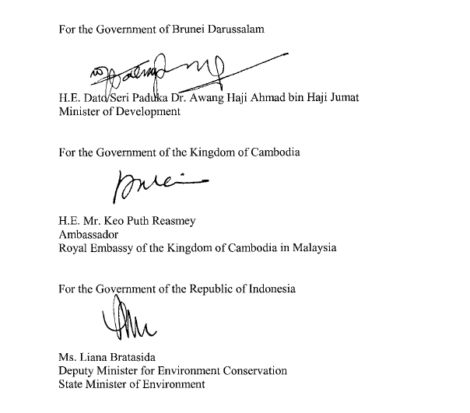

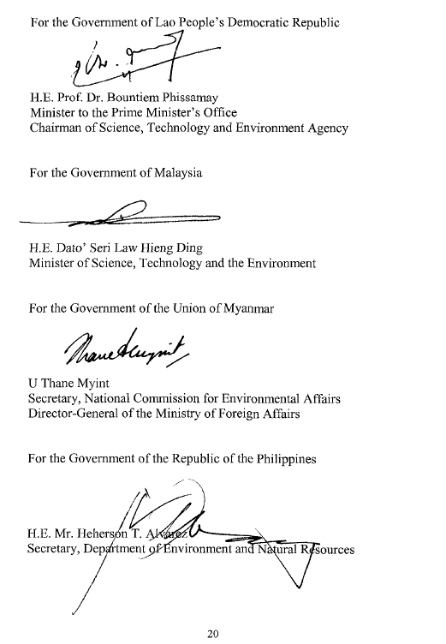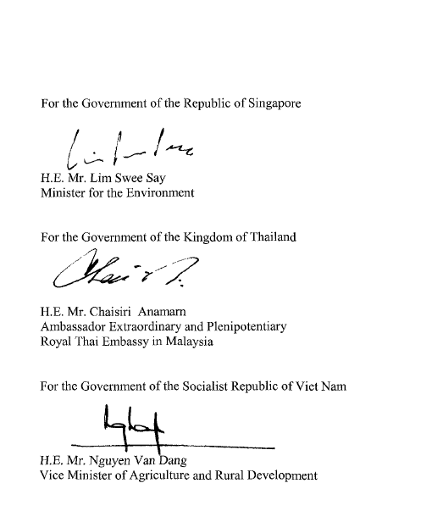

ANNEX. Terms of Reference of the ASEAN Co-ordinating Centre for Transboundary Haze Pollution Control
The ASEAN Centre shall:
1. Establish and maintain regular contact with the respective National Monitoring Centres regarding the data, including those derived from satellite imagery and meteorological observation, relating to:
a. Land and /or forest fire;
b. Environmental conditions conducive to such fires; and
c. Air quality and levels of pollution, in particular haze arising from such fires.
2. Receive from the respective National Monitoring Centres or Focal Points the data above, consolidate, analyse and process the data into a format that is easily understandable and accessible.
3. Facilitate co-operation and co-ordination among the Parties to increase their preparedness for and to respond to land and/or forest fires or haze pollution arising from such fires.
4. Facilitate co-ordination among the Parties, other States and relevant organisations in taking effective measures to mitigate the impact of land and/or forest fires or haze pollution arising from such fires.
5. Establish and maintain a list of experts from within and outside of the ASEAN region who may be utilised when taking measures to mitigate the impact of land and/or forest fires or haze pollution arising from such fires, and make the list available to the Parties.
6. Establish and maintain a list of equipment and technical facilities from within and outside of the ASEAN which may be made available when taking measures to mitigate the impact of land and/or forest fires or haze pollution arising from such fires, and make the list available to the Parties.
7. Establish and maintain a list of experts from within and outside of the ASEAN region for the purpose of relevant training, education and awareness-raising campaigns, and make the list available to the Parties.
8. Establish and maintain contact with prospective donor States and organisations for mobilising financial and other resources required for the prevention and mitigation of land and/or forest fires or haze pollution arising from such fires and preparedness of the Parties, including fire-fighting capabilities.
9. Establish and maintain a list of such donors, and make the list available to the Parties.
10. Respond to a request for or offer of assistance in the event of land and/or forest fires or haze pollution resulting from such fires by:
a. Transmitting promptly the request for assistance to other States and organisations; and
b. Co-ordinating such assistance, if so requested by the requesting Party or offered by the assisting Party.
11. Establish and maintain an information referral system for the exchange of relevant information, expertise, technology, techniques and know-how, and make it available to the Parties in an easily accessible format.
12. Compile and disseminate to the Parties information concerning their experience and any other practical information related to the implementation of the Agreement.
13. Assist the Parties in the preparation of standard operating procedures (SOP).

