2003 PROTOCOL TO AMEND THE ASEAN
FRAMEWORK AGREEMENT ON SERVICES
Signed in Phnom Penh, Cambodia on 2 September 2003

The Governments of Brunei Darussalam, the Kingdom of Cambodia, the Republic of Indonesia, Lao People’s Democratic Republic, Malaysia, the Union of Myanmar, the Republic of the Philippines, the Republic of Singapore, the Kingdom of Thailand and the Socialist Republic of Viet Nam, Member States of the Association of South East Asian Nations (hereinafter referred to as “ASEAN”);
RECALLING the Framework Agreement on Enhancing ASEAN Economic Cooperation signed on 28 January 1992 in Singapore, of which Article I paragraph 3 provides that all Member States shall participate in intra-ASEAN economic arrangements, provided that, in the implementation of these economic arrangements, two or more Member States may proceed first if other Member States are not ready to implement these arrangements;
RECALLING the decision of the ASEAN Economic Ministers (AEM) at their Retreat held in Genting Highlands, Malaysia on 6 July 2002 to accelerate services liberalization within Member States;
DESIRING to expedite the liberalization of trade in services within ASEAN through the implementation of the ASEAN-X formula, based on the parameters endorsed by the AEM at their 34th Meeting held in Bandar Seri Begawan, Brunei Darussalam on 12 September 2002;
NOTING the ASEAN Framework Agreement on Services (hereinafter referred to as “the Framework Agreement”) signed on 15 December 1995 at the Fifth ASEAN Summit held in Bangkok, Thailand, where Article II paragraph 1 provides that two or more Member States may proceed first if other Member States are not ready to implement cooperation arrangements under the Framework Agreement;
REFERRING to Article XII of the Framework Agreement, which provides for amendments;
HAVE AGREED AS FOLLOWS:
ARTICLE 1
The Framework Agreement shall be amended by adding a new “Article IV bis” immediately after the existing Article IV to read as follows:
“1. Notwithstanding the provisions of Article IV of this Framework Agreement, two or more Member States may conduct negotiations and agree to liberalize trade in services for specific sectors or sub-sectors (hereinafter referred to as “the participating Member States”). Any extension of such preferential treatment to the remaining Member States on an MFN basis shall be voluntary on the part of the participating Member States.
2. The participating Member States shall keep the remaining Member States informed through the ASEAN Secretariat of the progress or result of the negotiations, including the scheduling of commitments for the specific sectors or sub-sectors concerned. Member States wishing to join any on-going negotiations among the participating Member States may do so in consultation with the participating Member States.
3. Any Member State which is not a party to any agreement reached pursuant to paragraph 1 may in due course become a party to such an agreement upon making offers at similar or acceptable levels to the participating Member States.
4. The participating Member States can further refine the parameters for specific sectors or sub-sectors to be committed as may be mutually agreed by all participating Member States for the purpose of further liberalization of trade in services.
5. All agreements reached pursuant to paragraph 1 shall be deposited with the Secretary-General of ASEAN who shall promptly furnish a certified copy thereof to each Member State.”
ARTICLE 2
1. This Protocol shall enter into force on 31 December 2004.
2. This Protocol shall be deposited with the Secretary-General of ASEAN who shall promptly furnish a certified copy thereof to each Member State.

IN WITNESS WHEREOF, the undersigned, being duly authorised thereto by their respective Governments, have signed the Protocol to Amend the ASEAN Framework Agreement on Services.
DONE at Phnom Penh, Cambodia, on this 2nd day of September in the Year Two Thousand and Three, in a single copy in the English language.
For the Government of Brunei Darussalam: ABDUL RAHMAN TAIB, Minister of Industry and Primary Resources
For the Government of the Kingdom of Cambodia: CHAM PRASIDH, Minister of Commerce
For the Government of the Republic of Indonesia: RINI M. S. SOEWANDI, Minister of Industry and Trade
For the Government of the Lao People’s Democratic Republic: SOULIVONG DARAVONG, Minister of Commerce
For the Government of Malaysia: RAFIDAH AZIZ, Minister of International Trade and Industry
For the Government of the Union of Myanmar: U KHIN MAUNG WIN, Deputy Minister of Foreign Affairs
For the Government of the Republic of the Philippines: MAR ROXAS, Secretary of Trade and Industry
For the Government of the Republic of Singapore: B.G. (NS) GEORGE YONG-BOON YEO, Minister for Trade and Industry
For the Government of the Kingdom of Thailand: ADISAI BODHARAMIK, Minister of Commerce
For the Government of the Socialist Republic of Vietnam: TRUONG DINH TUYEN, Minister of Trade
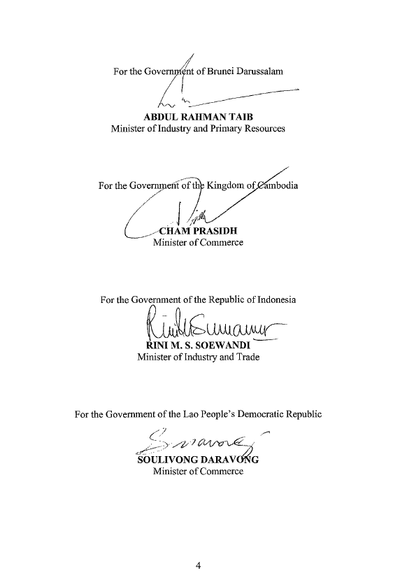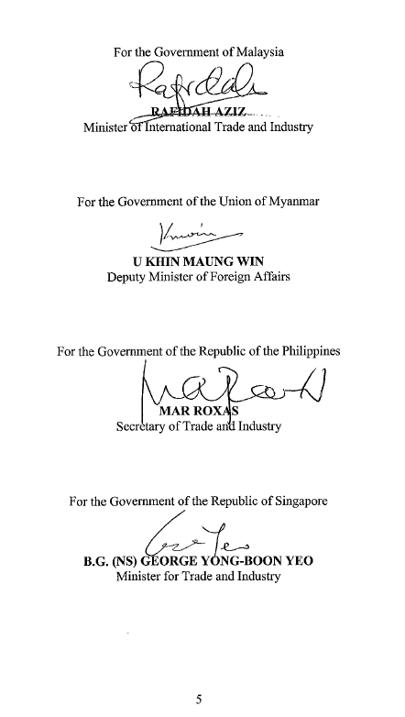
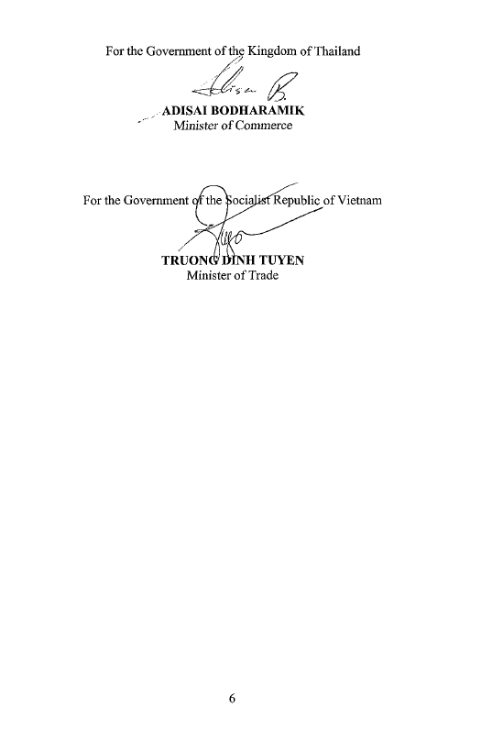
INTERPRETATIVE NOTES
TO THE PROTOCOL TO AMEND
THE ASEAN FRAMEWORK AGREEMENT ON SERVICES

Protocol | Interpretative Notes
Article 1, paragraph 1  Notwithstanding the provisions of Article IV of this Framework Agreement, two or more Member States may conduct negotiations and agree to liberalize trade in services for specific sectors or sub-sectors (hereinafter referred to as “the participating Member States”). Any extension of such preferential treatment to the remaining Member States on an MFN basis shall be voluntary on the part of the participating Member States. | This approach shall be used to expand and deepen liberalization of service sectors or sub-sectors, including sectors or sub-sectors agreed under the common sub-sector approach.  Any preferential treatment extended to the remaining Member States on a voluntary basis shall be unconditional, non-discriminatory and without the need for reciprocity.
Article 1, paragraph 2  The participating Member States shall keep the remaining Member States informed through the ASEAN Secretariat of the progress or result of the negotiations, including the scheduling of commitments for the specific sectors or sub-sectors concerned. Member States wishing to join any on-going negotiations among the participating Member States may do so in consultation with the participating Member States. | Consultation with the participating Member States shall be undertaken with a view to facilitate and encourage the participation of the remaining Member States.
Article 1, paragraph 3:  Any Member State which is not a party to any agreement reached pursuant to paragraph 1 may in due course become a party to such an agreement upon making offers at similar or acceptable levels to the participating Member States. | The reference to “acceptable level” here applies only to offers made by Member States wishing to join an agreement reached pursuant to paragraph 1 of Article 1 of this protocol and deemed acceptable by all the participating Member States, taking into account developmental differences, both in terms of economic and stage of development of the particular sector.  The participating Member States shall not require a higher level of commitments from the remaining Member States than their respective commitments under the agreement.
Article 2, paragraph 1:  This Protocol shall enter into force on 31 December 2004. | All Member States undertake to complete their internal procedures for the entry into force of this protocol on or before 31 December 2004 and to inform the ASEAN Secretariat of the date of completion.

