2011 Guidelines on the Use of the ASEAN Flag
Adopted in Jakarta, Indonesia on 6 May 2011

A. Dignity of the ASEAN Flag 2
B. Use of the ASEAN Flag 2

B.1. Use of the ASEAN Flag by ASEAN Member States 2

B.2. Use of the ASEAN Flag by the ASEAN Secretariat 3

B.3. Use of the ASEAN Flag by ASEAN Committees in Third Countries 3

B.4. Use of the ASEAN Flag by ASEAN institutions 3

B.5. Use of the ASEAN Flag by Countries, International Organisations and Entities Associated with ASEAN 4

B.6. Use of the ASEAN Flag in Mourning 4
C. Position of ASEAN Flag in the Flag Arrangements for ASEAN Meetings 4
D. Disposal of Worn Flag 5
E. Approval of and Amendments to the Guidelines 5
ANNEX 6

A. Specifications 6

B. Design of the ASEAN Flag 7

B.1. Table Flag 7

B.2. Room Flag 8

B.3. Car Flag 9

2011 GUIDELINES ON THE USE OF THE ASEAN FLAG
Adopted in Jakarta, Indonesia on 6 May 2011

- The ASEAN Flag is a symbol of Member States’ unity and support for the principles and endeavours of ASEAN and is a means to promote greater ASEAN awareness and solidarity.
- The ASEAN Flag represents a stable, peaceful, united and dynamic ASEAN. The colours of the Flag – blue, red, white and yellow – represent the main colours of the flags of all the ASEAN Member States.
- The blue represents peace and stability. Red depicts courage and dynamism, white shows purity and yellow symbolises prosperity.
- The stalks of padi in the centre of the Emblem represent the dream of ASEAN's Founding Fathers for an ASEAN comprising all the countries in Southeast Asia, bound together in friendship and solidarity.
- The circle represents the unity of ASEAN.

- The ASEAN Flag is the reserved copyright of ASEAN.
- The specifications of the ASEAN Flag are annexed.

Dignity of the ASEAN Flag
- The ASEAN Flag shall be treated with respect and shall not be subjected to any indignity.

Use of the ASEAN Flag

B.1. Use of the ASEAN Flag by ASEAN Member States
- ASEAN Member States shall use the ASEAN Flag in the manner specified under these guidelines that include the following:
- The ASEAN Flag shall be displayed at all ASEAN National Secretariats.
- The ASEAN Flag shall be displayed on a permanent basis at Diplomatic and Consular Missions of ASEAN Member States alongside the national flag. The ASEAN Flag shall be displayed by the ASEAN Member States in third countries which are recognised by all ASEAN Member States.
- The ASEAN Flag shall be displayed alongside the national flag in the following manner:
Diagram 1: Outdoor Flags Diagram 2: Venue Flags (Outdoor/Indoor)
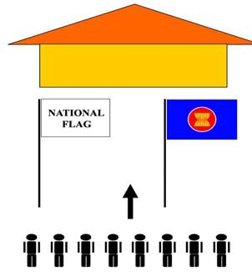

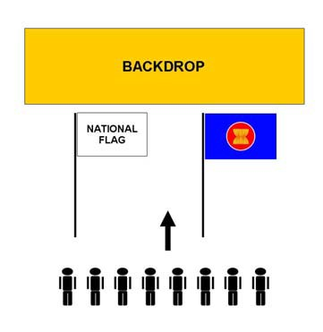

- The ASEAN Flag shall be displayed during ASEAN meetings, ASEAN Day Celebrations, ceremonies and functions held in Member States.
- The display of the ASEAN Flag shall be in accordance with national laws and regulations of the respective countries and the provisions under these Guidelines.

B.2. Use of the ASEAN Flag by the ASEAN Secretariat
- The ASEAN Secretariat shall use the ASEAN Flag in the manner specified under these guidelines that include the following:
- Display at the Secretariat buildings and residence of the Secretary- General;
- During ASEAN meetings;
- On the official vehicle of the Secretary-General of ASEAN during official functions; and
- During ASEAN Day celebrations, official functions, ceremonies, exhibitions, gatherings or any other occasions organised by the ASEAN Secretariat in its effort to promote the interest of ASEAN.

B.3. Use of the ASEAN Flag by ASEAN Committees in Third Countries
- ASEAN Committees in Third Countries shall also display the ASEAN Flag during ASEAN Day celebrations, official functions, ceremonies, exhibitions, gatherings or any other occasions in its effort to promote the interest of ASEAN.

B.4. Use of the ASEAN Flag by ASEAN institutions
- ASEAN institutions shall display the ASEAN Flag at their premises as well as during ASEAN meetings, ASEAN Day celebrations, official functions, ceremonies, exhibitions, gatherings or any other occasions in its effort to promote the interest of ASEAN.

B.5. Use of the ASEAN Flag by Countries, International Organisations and Entities Associated with ASEAN
- Countries which have relations with ASEAN, International Organisations which work closely with ASEAN and entities associated with ASEAN may display the ASEAN Flag in support of activities related to ASEAN.

B.6. Use of the ASEAN Flag in Mourning
- Upon the passing of a Head of State or Government of a Member State, the ASEAN Flag will be flown at half-mast at the ASEAN Secretariat building and other ASEAN institutional buildings for an official mourning period. The ASEAN Flag may also be flown at half-mast in special circumstances, including natural calamities in ASEAN Member States, upon the approval of all ASEAN Member States.
- Member States will decide if the ASEAN Flag should be flown at half-mast in their respective countries as well as the period of mourning.

Position of ASEAN Flag in the Flag Arrangements for ASEAN Meetings
- The ASEAN outdoor/venue and room flag shall be displayed together with the flags of ASEAN Member States in alphabetical order, based on the names of Member States, starting from Brunei Darussalam on the extreme left and with the ASEAN Flag always on the extreme right after the national flag of Viet Nam, in the following manner:
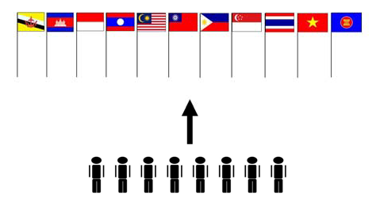
- When placed with the flag of a Dialogue Partner, the ASEAN Flag along with the flags of ASEAN Member States shall be displayed in the following manner:
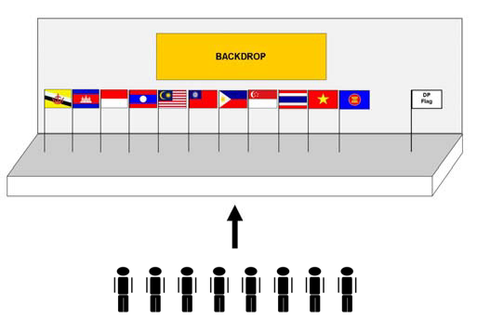
- The ASEAN table flag shall be displayed at the left side of the name plaque of the ASEAN Secretariat, in the following manner:
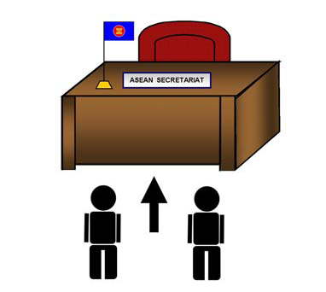

Disposal of Worn Flag
- When the ASEAN Flag has become worn or torn or frayed, it shall not be displayed, and shall be properly disposed of.

Approval of and Amendments to the Guidelines
- The Guidelines shall be approved by the ASEAN Coordinating Council (ACC).
- Any Member State may propose amendments to the Guidelines, which shall be submitted to the Committee of Permanent Representatives (CPR) for its consideration and agreed upon by consensus. The agreed amendments shall be submitted to the ASEAN Coordinating Council (ACC) for notation, and thereafter come into immediate effect.

ANNEX

A. Specifications
- The specifications of Pantone Colour for the colours of the ASEAN Flag are:
Background : Pantone 19-4053
TC/Pantone Blue 286
Outer Ring : Pantone 11-4202
TC/Plain White
Circular Area : Pantone 18-1655
TC/Pantone Red 032
Rice Stalks : Pantone 13-0758
TC/Pantone Process Yellow

B. Design of the ASEAN Flag
- The ASEAN Flag comes in four versions, namely, the Table Flag, Room Flag, Car Flag, and Outdoor/ Venue Flag. While the colour specifications are the same for all versions, the measurements and materials used differ.

B.1. Table Flag
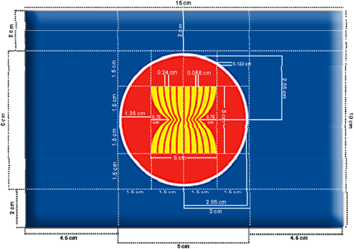
Measurement and Material:
Size : 10 cm x 15 cm
Emblem Diameter : 6 cm
Material : Polyester – Nylon
Process Technique : Screen Printing; Sewing
Finishing : Double stitch on sides

B.2. Room Flag
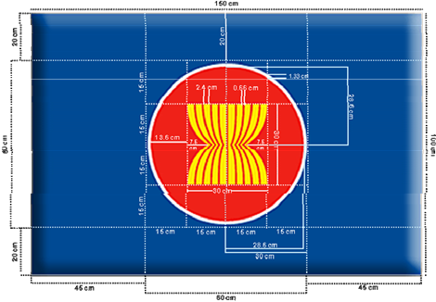
Measurement and Material:
Size : 100 cm x 150 cm
Emblem Diameter : 60 cm
Material : Polyester – Nylon
Process Technique : Screen Printing; Sewing
Finishing : Double stitch on sides

B.3. Car Flag
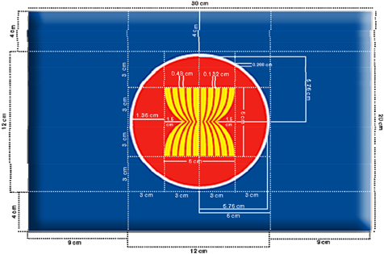
Measurement and Material:
Size : 20 cm x 30 cm
Emblem Diameter : 12 cm
Material : Polyester – Nylon
Process Technique : Screen Printing; Sewing
Finishing : Double stitch on sides
B.4. Outdoor/Venue Flag
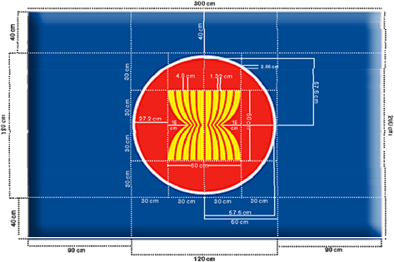
Measurement and Material:
Size : 200 cm x 300 cm
Emblem Diameter : 120 cm
Material : Polyester – Nylon
Process Technique : Screen Printing; Sewing
Finishing : Double stitch on sides

Note: The Guidelines were adopted at the 8th Meeting of the ASEAN Coordinating Council (ACC), Jakarta, 6 May 2011.

